**Assignment 15.6**

**Problem statement :**

**Build and Deploy Hadoop word count program using Gradle**

I am creating a Folder named **Hadoop_app_gradle** and inside the **src/main/java** directory, I am writing the Wordcount program

**Gradle Build Command:**

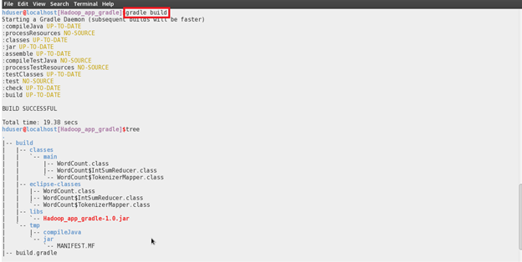

**Building the Project using the Gradle eclipse Command:**

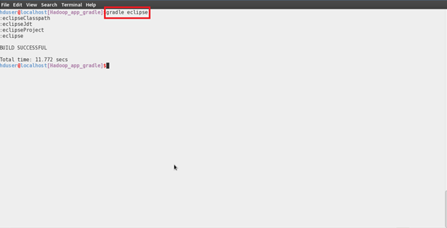

**Importing the project into the eclipse:**

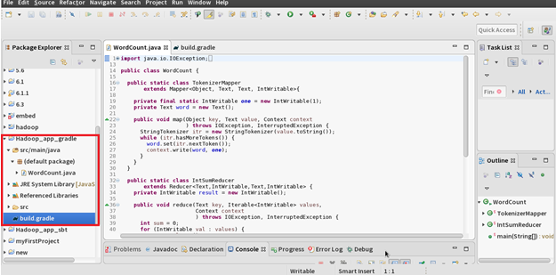

**Jar Created in the target folder:**

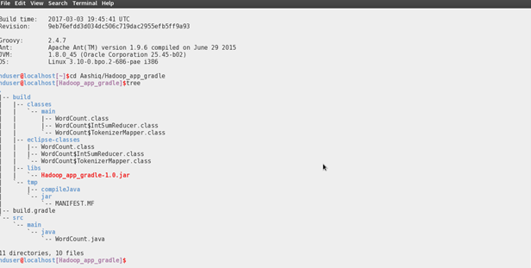

**Running the Jar File:**

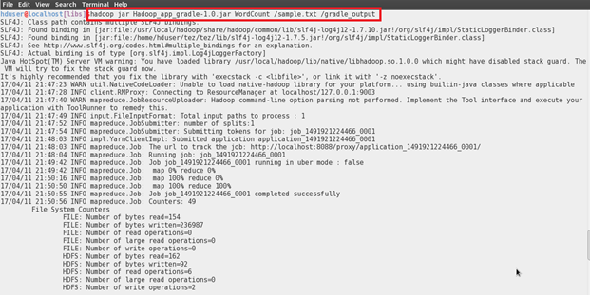

**Output:**

